**Overview**

Office Online for Box is a new feature that allows the editing and Shared co-editing of documents in Word, Excel and PowerPoint through your internet browser. Because this is through your web browser, you don’t need to have Microsoft Office installed on your computer. This is helpful if you are traveling or need to quickly edit a file on a computer that doesn’t have these Office programs available. Office Online for Box lets you edit your files straight from your Box account, and as mentioned earlier, allows them to be edited by more than one person at a time. Using Office Online for Box removes the need to save the file or re-upload it, as any changes are instantly saved and highlighted for group collaboration.

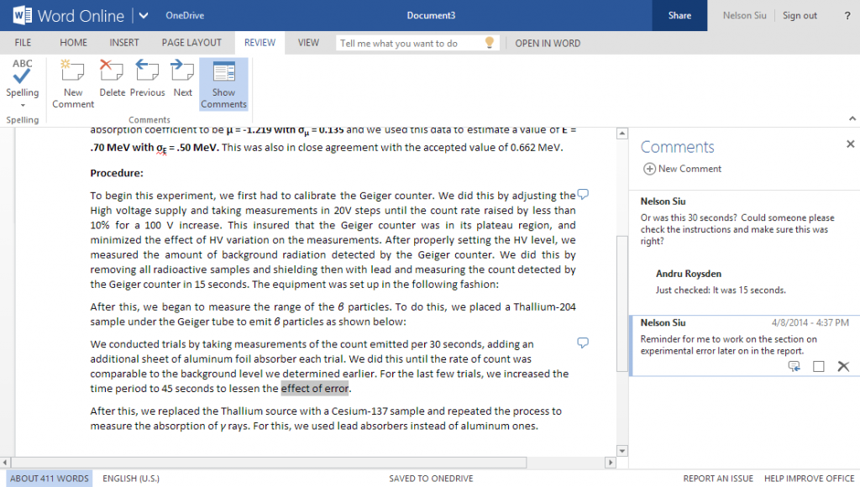

Using Word with Office Online for Box is great for collaboration. Live edits are highlighted, comments can be added, and all changes are saved to Box without the need to  
re-upload files.

**Set-Up and Configuration**

Office Online for Box is already available to all CAA users.

To sign in:

* 1. Log into the CAA Box website.
  2. Select a Word, Excel or PowerPoint document.

1. Right click on the document, and select **Open with - Office Online.**

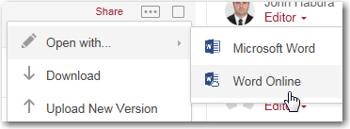

1. Once opened, you’ll be able to edit the document.
2. When you are finished with the file, make sure you save it specifically back to Box, as you have also have the option to save it to your computer. The black bar below will appear at the top of your screen when you have successfully saved it to Box.



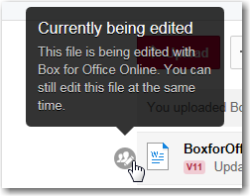

While in collaboration, highlights will appear instantaneously to show recent edits. You can check if someone else is editing the file by looking for the gray circle icon next to the file name.

**FAQs**

* **Do I need to have a Box account?**

Your usual CAA Box account is all you need to edit and share files, and you can access it from  
any device.

* **What file types are compatible?**

Only the latest file versions of Office can be used in Office Online for Box. These file names end with an “x”, such as .docx, .xlsx, and .pptx. Older files, such as .doc, .xls, and .ppt, will not work.

* **I cannot find an option in Word that is usually available. Where is it?**

Office Online for Box does not have all of the advanced features normally found in the Office programs. If a function you want is missing, you'll have to use the Office programs installed on your computer.